Agenda

* Gini uses AUC
* Credit Risk Modelling
* Weekly Plan
  + Project Plan
    - Research Objectives
    - Project Milestone
    - Deliverables
    - Work Task Allocation
    - Scheduling

Minutes of Meeting

* Gini, ROC
* Discuss difference between ROC and AUC. Didn’t finalise on any yet.
* Discuss on AUROC
  + Either right or wrong

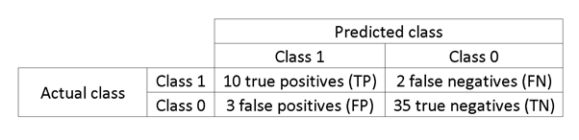

* + TPR (True positive rate)
    - TPR = TP/(TP + FN)
  + FPR (False Positive rate)\
    - FPR = FP/(FP+TN)
  + TPR + FRP = 1
* Project Plan
* Research Objectives
  + Josh proposed that we can have different approaches States such as looking into the relationship between states: to see if there’s richer states
  + Team members are expected to do the exploratory data before Friday and finalise on Friday’s discussion
* Project Milestone
  + Categories/List out the project milestones as follow
    - Defining problem
    - Exploratory Data analysis & Literature Review - Week 1
    - Understanding and cleaning the data
    - Apply variable selections, algorithm and heuristic
    - Fit GLM
    - Model selection
    - Validation
    - Evaluate and draw conclusion.
    - Create Report
* Deliverables
  + Comparison of traditional model and the proposed model
* Work Task Allocation
  + Will breakdown the milestone into smaller tasks
  + Assigned to Vinnie
* Scheduling
  + Team has decided to use waterfall methodology
  + Critical Path will be created according to task
  + Gantt Chart will be created according to task
  + Assigned to Vinnie
* This Week’s Task
* Vinnie:
  + Gantt Chart
  + Work Task Allocation
* Everyone:
  + Literature Review
  + Data Exploratory